Test Readiness Review Report

Bryson Potts, Joseph Earnest, Manning Owens, Steven Harrington, Tamara McCaskill

Florida State University, Panama City

EML 4551C – Senior Design 1

Dr. Damion Dunlap



**Table of Contents**

**Project Overview** **3**

**Project Background** **3**

**Boat Specifications and Status Update** **4**

**Assessment Plan** **5**

**Safety Plan** **5**

**Remaining Items** **6**

# 

# 

# 

# 

# 

# 

# 

# 

# 

# 

# Project Overview

The goal of our project is to design and build a boat with autonomous function capable of completing the course objectives for the 2021 RoboBoat Competition.

# Project Background

RoboBoat is an international competition hosted by RoboNation in Daytona, Florida. Competitors create autonomous surface vehicles (ASV) to complete simplified tasks. The tasks simulate real world challenges found in the maritime industry such as surveillance, object delivery, and navigation.

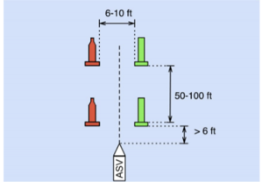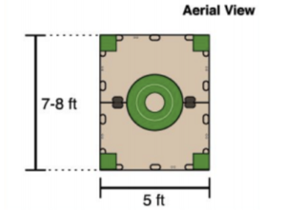

As a result of COVID, The RoboBoat 2021 competition was held online. Deliverables that we had to create for the competition were a short skills video, detailed technical report and a team website (<https://pcspear.org/the-2020-2021-team/>).

# Boat Specifications and Status Update

**B.O.A.T Specs:**

-Length is 1.2 meters

-Height is 0.7 meters

-Material of construction is E6 Fiberglass.

-Weight estimate of Hull + Lid is 13.26 Kg or 29 lbs. (SolidWorks material estimate)

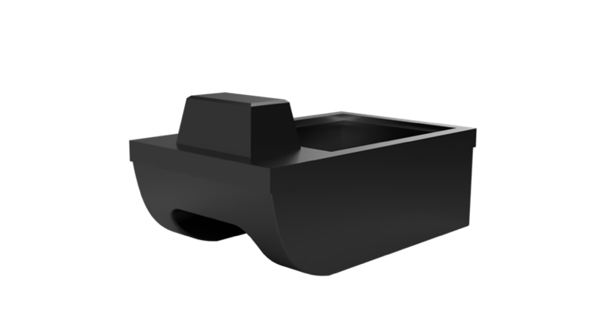

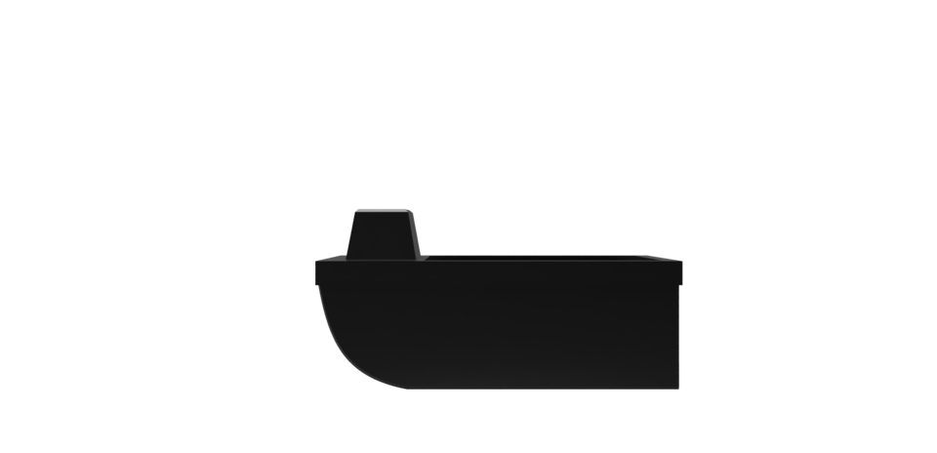

**Status Update:**

We were unable to manufacture B.O.A.T at Gulf Coast, therefore we had to make a mold and layup B.O.A.T by hand out of fiberglass and epoxy resin. Electronics will be installed on Monday, July 19. Testing will begin immediately after the electronics are implemented.

# Assessment Plan

In our testing one thing we will observe and assess is the floatation of the boat. We will see how it floats, if it can float for at least 30 minutes and it has the desired stability. Concerning the stability, we will see if it sits level and if it flips when and where force is applied. Once the electrical engineers implement all the electronics we will see how well the LiDar system works and the ease of changing out the propellers using the propeller hot swap method we came up with. Lastly, we will observe and see how well the boat performs and if any changes/tweaks need to be made.

The table below shows the order of the test, and the targets/metrics that are associated with each.

|  |  |  |
| --- | --- | --- |
| Test | Target | Metric |
| Floatation | Float for at least 30 minutes | Time floating without taking on water |
| Stability | Sit level in the water | Use level to see stability in water |
| Sub-Systems | LiDar tilt mechanism works  Propulsor hot swap works | LiDar scan has good visibility  Propulsors can be easily swapped |
| Operation | Boat has all electronics implemented and functions | A combination of all the above metrics. |

# 

# Safety Plan

With testing, there are a few safety concerns such as someone falling in water, the boat flipping/sinking, the boat getting stranded in the middle of water, the boat catching on fire, and a collision between boat and obstacles. To avoid these concerns we will ensure no one is running near water, have floatation devices on hand, ensure the boat is fully charged, ensure connections are secure, start at low power and incrementally move to high power, have a fire extinguisher on hand, and clear unwanted obstacles from the water.

# Remaining Items

To finish off this semester and our project we have the following deliverables due:

* Final Presentation - DR6 (7/26)
* Final Demonstration Video (7/26)
* Final Poster (7/26)
* Final Report (7/30)
* Create Operation Manual (7/30)
* Finalized Webpage (7/30).

# Gantt Chart

